**The overview of the whole project**

**Introduction:**

We have established an intelligent robotic nurse system to replace the nurse's functions to a certain extent, and remotely assist the doctor to complete the work of helping patients take medicines and carry out daily inspections. With the help of this system, the doctor can remotely command the robot to go to the pharmacy to send the medicine to the patient through the WeChat, and remotely obtain key information such as the patient's signs through the dialogue between the robot and the patient, and judge the subsequent treatment plan based on the information.

**The frame of the whole project:**

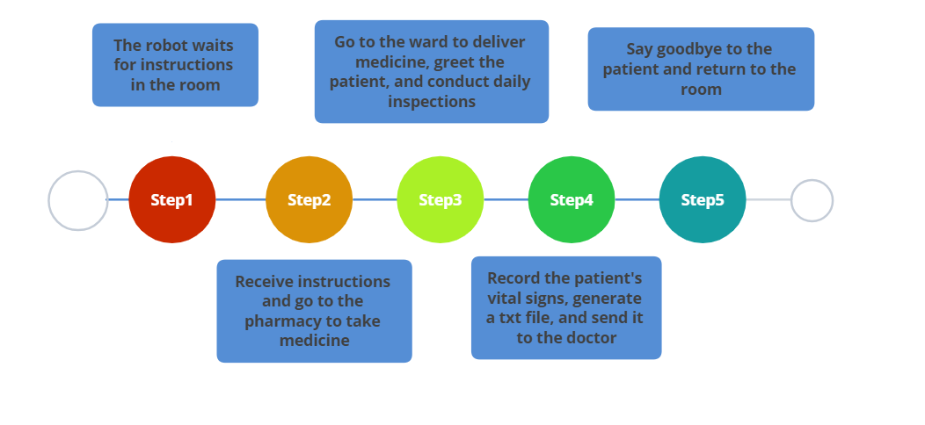

**Used technology:**

* Navigation function provided by turtlebot_navigation
* Online voice recognition provided by XunFei
* Expression recognition function provided by Baidu AI
* WeChat remote communication function provided by itchat

**The Speech Part**

**Introduction:**

We implemented the speech part based on the speech recognition module provided by xfei_asr and sound function provided by sound_play. I wrote a python script that declare a subscriber and a c++ source file that declare a publisher to implement this function. The topic subscription relationship is shown in the figure below (Figure 1). The robot can determine the way to greet the patient based on the results of the expression recognition. In addition, it can also assist in the daily inspection work, such as asking the patient's body temperature, blood pressure and other signs, to generate a txt document, which will be transmitted to the doctor through WeChat to help him make a judgment.

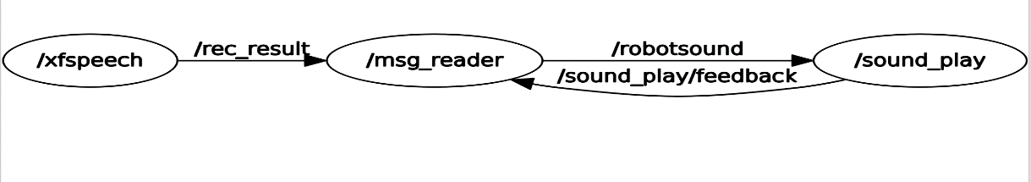

Figure 1

**The frame of this part:**

The patient speaks

Speech recognition by XunFei

Analyze recognition results and record key information

Send the generated txt file via WeChat

**Technical details:**

We mainly use the voice recognition function provided by XunFei. XunFei provides a program interface for speech recognition, which can realize online speech recognition by converting the heard sound into text in real time. In our project, I wrote the my_publish.cpp file based on the iat_publish_speak.cpp file for speech-to-text provided in xfei_asr, which declares a publisher that can convert the sound it hears into text every 15 seconds and publish it to the /rec_result topic as a String.

Then I wrote the msg_reader.py file to declare a subscriber which can receive the String mentioned above and make an analysis to record the key information in a txt file. For example, when the message contains keywords such as 37, 38, it will be judged as body temperature information and recorded in the column of body temperature. When the daily inquiry is over, a txt document like the one shown below will be generated, recording the patient's signs. All the work will start when the robot arrives at the ward.

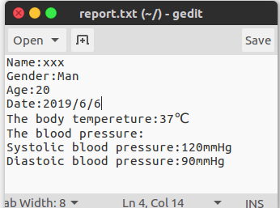

Figure 2

This txt document will be sent to the doctor remotely via WeChat at the end using the features provided by itchat.